Facebook – NCO Command Rollout

With roughly 10 million users in New York, Facebook provides a localized, targeted platform for conversation, and has the potential to dramatically increase engagement between the NYPD and the residents of New York. An average user logs in to Facebook 10 times a day[1], and uses it as a platform to connect, build and maintain relationships, share information and raise questions. Nowhere is the potential more apparent than in the NCO commands, where officers are building relationships and responding to quality of life and other community concerns.

Facebook also allows the precinct commander to put his or her finger on the quality of life concerns in the community, and address them both off and online. The reward comes not only when the concern is addressed, but when it is posted publicly to social media, closing the circle and satisfying the residents, who then share the good news with their networks.

Precinct Accounts

Currently, only NCO commands are to be considered for Facebook pages. Commands that have been selected will be contacted by Deputy Commissioner, Strategic Communications (DCSC.)

Account Establishment

DCSC will open each Facebook “user” and “page” for the command, and will create pre-made content before the account is made public.

**User:** The user account is used to log in and update the page. According to Facebook guidelines, the user account needs to be opened under the name of the person managing the account, in this case the commanding officer. However, no photo or any other identifying information will be attached. In addition all privacy settings will be enabled so that no other Facebook user can “friend request” “tag” direct message or Google search the user. This account is for log in purposes only. The email associated with the account and the password will be provided to the command by DCSC.

**Page:** The page is the actual platform that the public can view. The page names follow a similar naming scheme, aka “NYPD 34 Precinct”, “NYPD 23 Precinct” etc. They will be opened under the “Company, organization, institution” Facebook category and in the “Government organization” sub-category.

Content

The following content will be posted on the page by DCSC prior to its initial launch:

**Cover Photo –** each precinct page will feature a standardized permanent photo featuring 3-5 officers or NCOs standing outside the command or at a well-known location in the area. The photos will include a legal disclaimer and may not be changed by commands. Photos and subsequent design will be coordinated by DCSC.

**Profile Photo** – the profile photo is that of the commanding officer. Commands may not change their profile photo, unless in accordance with mourning band procedures.

**NCO Posts -** Each precinct page will feature a profile of each NCO sector in that command. The profiles will consist of a photo of the officers, a map of their sector, a short interview with each officer and their Department email addresses. All NCO profiles will be created by DCSC in coordination with the NCO Sgt. who will facilitate the interviews and photo shoots.

**“About” Section** – the “about” section will be populated by DCSC and should not be changed by commands. It will include the command address, phone number and email of the command’s choosing. In addition the following information will be added:

*Short Description* ***-*** *Welcome to the XXth Precinct's official Facebook page, serving the residents of “specific neighborhood/s” in “specific borough”*

*Impressum* ***-*** *For emergencies, dial 911. To submit crime tips & information, visit www.NYPDcrimestoppers.com or call 800-577-TIPS.*

*Long Description -**This is a page for residents and the community of “neighborhood/s” to engage with their police, receive updates and discuss matters affecting their neighborhood.*

*Please treat your neighbors with the same respect as if you were meeting them face to face.*

*Please limit discussion to issues affecting “neighborhood/s”.*

*Offensive or profane content may be removed by moderators.*

*We do not endorse any advertisements that may appear on this page.*

*ALWAYS report crimes in progress and other emergencies to 911, and 311 for non-emergencies*

*New York City Social Media policy:* [*http://www.nyc.gov/html/misc/html/social_media_policy.html*](http://www.nyc.gov/html/misc/html/social_media_policy.html)

*Phone number: Precinct main number*

*Website: Official NYPD Page*

Account Operation

Each account will be operated by the NCO Sgt./admin staff together with 1-2 additional people of the commanding officer’s choosing (often these will be the officers currently operating the command’s Twitter account.) Though the account will be open in the commanding officer’s name and written on his or her behalf, they are not required to update and maintain the page themselves. The account operators will be responsible with updating the page, responding to concerns and monitoring it as often as needed. The CO is ultimately responsible for the overall content on the page.

IT needs

Commanding officers should submit a 49 to Deputy Commissioner, Information Technology requesting social media access for all account operators on their desktop and mobile devices.

Posts

Commands should strive to post standalone posts 3-5 times a week and no more than twice daily. A good post will consist of:

* 1 -2 paragraphs of text.
* A photo(s), though it is not required.
* Information relevant to the neighborhood.
* Original content created by them or a member of the community. Sharing posts from other pages is discouraged.
* *Appropriate content*: Crime prevention information, safety tips, updates about events in the commands, community events, personal stories, positive posts from community members, good arrests and community cooperation. Each command should strive to balance between “hard” crime posts and posts about activity in the community.
* *Inappropriate content*: citywide or nationwide politics, fundraising events (unless approved by the Legal Bureau) short generic messages (“Good Morning,” “Happy Friday” etc.) motivational quotes, images that do not meet the NYPD style guide standards, photos taken without permission.
* Cross-posting from Twitter to Facebook and vice versa is prohibited. Accounts may post the same content but may not directly publish from one platform to the other.

Expanding your Audience

A good way to get the attention of local residents to your page is to “Like” other pages. You can search for any community organizations, historical landmarks, schools or cultural/religious centers on Facebook and then “Like” them as your page:

1. Go to the Page you want to “Like”
2. Hover over “More” below the Page's cover photo
3. Select “Like as Your Page”
4. Select a Page and click “Save”

Commander’s Corner

Commands are encouraged to post a weekly message from the CO, giving an overview of the week and discussing any community issues or upcoming events. This can be done in text or video. The update doesn’t have to be comprehensive, but should include relevant information to the community.

Responding to concerns

The precinct Facebook account and operator in conjunction with the NCO Sgt. should use the platform to address concerns and questions. For many New Yorkers, Facebook is the easiest and most effective way to have a conversation with their local precinct, aside from attending monthly community council meetings. It is the responsibility of the account operator to assure that comments and questions are being addressed when possible, though not all concerns may warrant a response. However, any command-wide events and incidents that may be irregular should be addressed BEFORE posting any unrelated content to the page. This could be anything from a shooting to an act of vandalism - if it is a topic of conversation and affecting many people, it should be addressed in a post.

DCSC staff is available to help with wording and sensitive situations. There are four types of responses:

1. Response to posts on page.
2. Response to direct messages (private)
3. Response to comments:

If someone comments on a post the account operator can respond by clicking “reply” to that specific comment.

1. Response to trends/concern in other pages:

Often times a concern will be raised by people in another relevant Facebook page which will then “tag” the precinct. For example, a discussion might take place on a neighborhood forum page were people will be complaining about a quality of life issue or an event that recently took place. If a concern is raised by several people and is being discussed, the precinct should attempt to address it in an independent post on its page.

Example: Question on external community page with 63 comments in discussion:

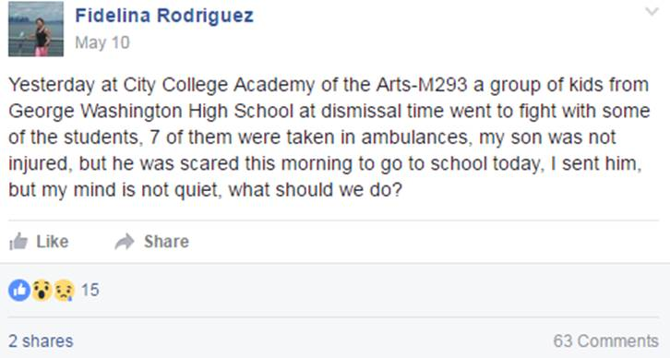

Response on NYPD 34 precinct Facebook page:

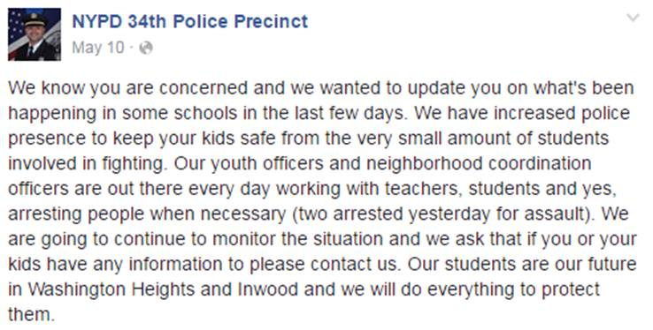

Response to 311/911 posts

Though we prefer residents’ call 311 with quality of life complaints and strongly encourage them to call 911 in emergency situations, it is inevitable that many will take to Facebook to share this type of information. When they do, it is our responsibility to address it when we see it. A response should include:

1. A reminder to call 311 or 911 and that the page is not monitored 24/7, as per the disclaimer.
2. Information for the relevant NCO if location is mentioned.
3. If location is not mentioned, a response asking for more information/location.
4. And indication of whether the conditions are or have been addressed.

Compromised account and/or response to threat

Comply with Interim order 22-2016 “Department social media accounts and policy” and with patrol guide procedure 221-19 “Threats against members of service” Additionally, if a threat is made against a police officer, the NYPD or public figure, please report it to intel at NYCsafe@NYPD.org

Allegations of corruption, misconduct or civilian complaints

Patrol Guide procedures 207-22 and 207-31 mandate that members of the service who become aware of allegations of corruption, misconduct or civilian complaints report said allegations to: (1) the commanding officer or (2) the Internal Affairs Bureau.

Emergency Procedure

In case of emergency, refer to operations order 9-2016 “Social Media Plan: Emergency Incidents”

Removal of Content/Users

Only content that violates the New York City Social Media policy should be removed from the page:

*NYC social media accounts are not open to comments promoting or opposing any person campaigning for election to a political office, or promotion or advertisement of a business or commercial transaction.*

*The use of obscene, threatening or harassing language is prohibited.*

*Personal attacks of any kind or offensive comments that target or disparage any ethnic, racial, age, or religious group, gender, sexual orientation or disability status are prohibited.*

*Comments advocating illegal activity or posting of material that violates copyrights or trademarks of others are prohibited.*

*This comment policy is subject to amendment or modification at any time.*

Commands should utilize the “hide” feature rather than the “delete” feature to remove content from the page. In a case that an account operator would like to remove content that does not violate any of the above, he or she must confer with DCSC staff.

Banning users is prohibited; specific cases should be brought to the attention of DCSC and DC Legal Bureau.

1.       <http://www.nbcnews.com/technology/smartphone-users-check-facebook-14-times-day-study-says-1C9125315>