How to get started with HootSuite.
Once you set up an account and log in, HootSuite will guide you through the basics of connecting networks and organizing streams.
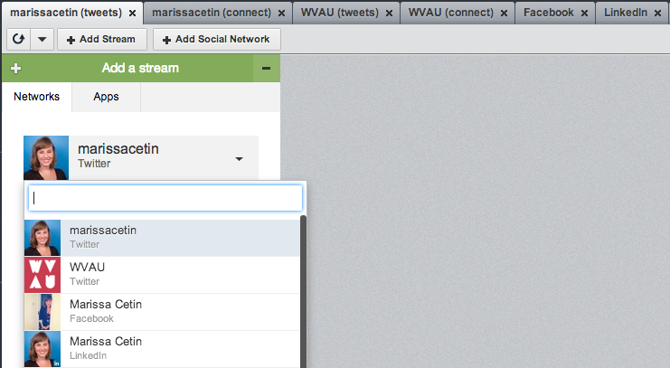
The green menu tab displays the networks connected to your HootSuite account. From there, select the streams you'd like to monitor, such as your timeline, mentions and scheduled tweets.
The stream options vary for each network (for example, Facebook's options include News Feed, statuses, events and Wall posts), but the simple, no-frills layout remains the same.
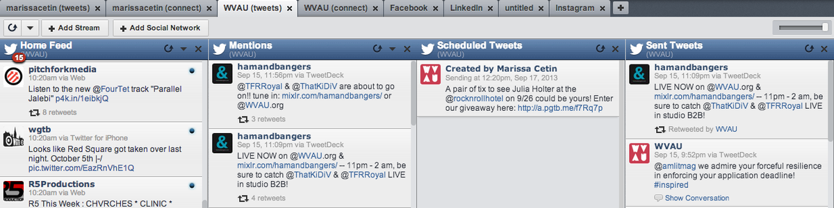
HootSuite is optimized for managing Twitter accounts, but you can also post to your personal Facebook and LinkedIn accounts, as well as to pages and groups of which you're a member or administrator. HootSuite will not connect to personal Google+ profiles, but it allows you to manage your pages.
For free accounts, HootSuite initially limits each tab to only three streams, but opening multiple tabs seems to override that rule. Even so, streams are so easily closed, reopened and refreshed that the initial limit is only a minor annoyance. There are no rules against limiting one Twitter account to one tab.
Take advantage of quick customization (click on a tab's name to edit) to open more streams. Group your timeline, sent tweets and scheduled tweets under one tab, and then open a "connect" tab with mentions and direct messages.
Use the search option to create a stream for a specific hashtag, or to get involved in a Twitter chat. Use the refresh button at the top right to stay updated.
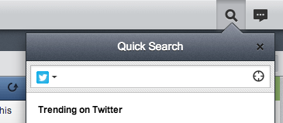
In addition to in-stream search, you can search for the latest happenings on Twitter with "Quick Search" at the top-right of the web app window. The search box appears on top of the page and it will remain within your workspace — a smart feature when balancing several tabs and streams. This search box will also reveal what is currently trending worldwide.

Posting to Your Networks
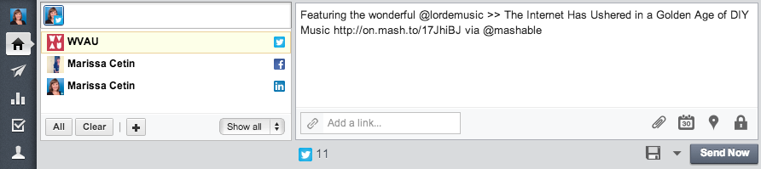
HootSuite's message-composing features follow suit with its simplicity. At the top of the page, you can create a new post to send to any one, two or all of your connected accounts. If you decide to change or remove the accounts you wish to post to, click on the icon in the top box:
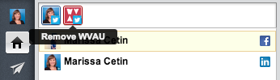
Scheduling is HootSuite's most social media manager-friendly tool, allowing you plan ahead and keep your account actively engaged in just a few clicks. Scheduling can be found below the text field in the compose box. Select the date and time of your choosing, and click "Schedule" when the post is ready to go. 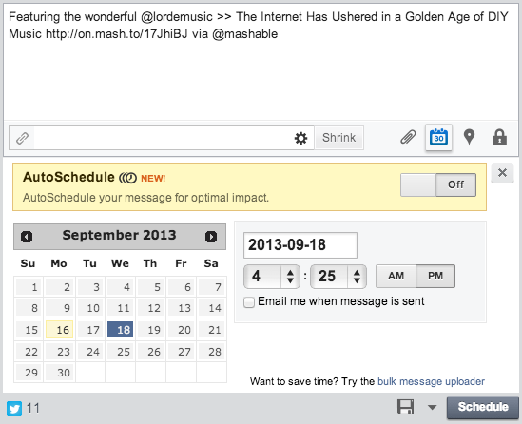

Security
Social media security is important not only for work or professional accounts, but also your private personal data, which can be dangerous if placed in the wrong hands. More social networks are stepping up their security game, such as Twitter's recent two-step authentication, and HootSuite is no different.
HootSuite enables login through Google, Yahoo, Open ID, Facebook and Mixi to make your social account inaccessible to someone who cracked your password.
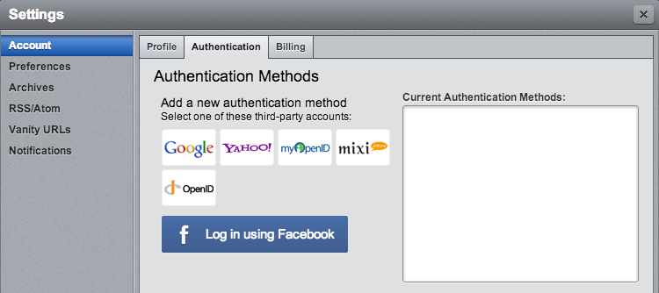
To make your account more secure, find this option under Settings > Account > Authentication, via the left sidebar. Choose how you would best prefer to connect to HootSuite, and the sites will guide the rest of the setup.

Mobile
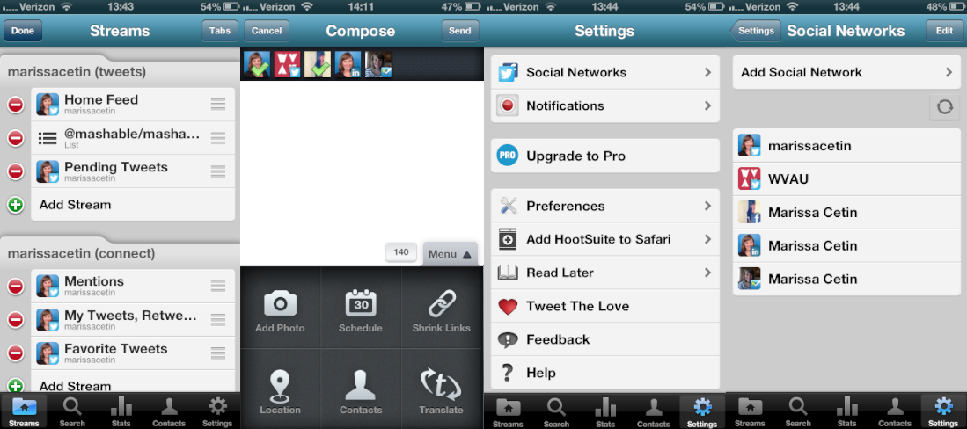
HootSuite's mobile app (for iOS and Android) follows the web app's use of simple categories and tabs to keep everything organized, much like an outline of your social networks. Within tabs, you can smoothly side-swipe between the streams for quick access.
The mobile app is perfect for checking on your accounts while on the go, or even when your laptop is on the other end of the couch. With virtually all the same functionality and customization, HootSuite's mobile app keeps you on top of your social presence and modify scheduling in the case of unexpected events.
.

